Name: Mahmoud reda atta sec : 7

Quiz 1

In the Hypothetical Machine the contents of memory was as shown. And PC contents is 300. Show the contents of memory and PC , AC , IR after execute three instructions (three fetch cycle and there execute cycle)

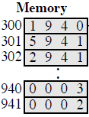

Show the contents of PC , AC and IR and memory after the execution of each instruction of the following program on the Hypothetical Machine:

300 LOAD 550

301 ADD 551

302 STORE 600

Where the contents of memory at 550 is 3 and at 551 is 4.

The following figure provide the main characteristics of Hypothetical Machine.

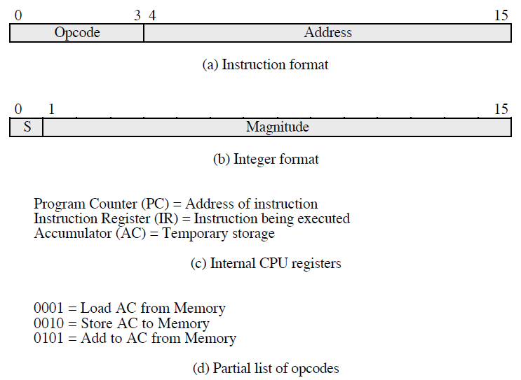

The hypothetical machine also has two I/O instructions:

0011 = load AC from I/O

0111 =store AC to I/O

In these case, the 12-bi address identifies a particular I/O device. Show the program execution for the following program:

1. Load AC from device 5.

2. Add contents of memory location 940.

3. Store AC to device 6.

Assume that the next value retrieved from device 5 is 3 and that location 940 contains a value of 2.

**<<ANSWER>>**

**NAME : NOURAN TARQI SEC : 8**

**<1>**

**FETCH EXECUT**

|  |  |
| --- | --- |
| AC : 0000  IR : 1940 PC : 300  ----------------------------------------------------------  940 :0003  941 :0002 | AC : 0003  IR : 1940 PC : 300  ----------------------------------------------------------  940 :0003  941 :0002 |
| AC : 0003  IR : 5941 PC : 301  ----------------------------------------------------------  940 :0003  941 :0002 | **AC : 0005**  **IR : 5941 PC : 301**  **----------------------------------------------------------**  **940 :0003**  **941 :0002** |
| AC : 0005  IR : 2941 PC : 302  ----------------------------------------------------------  940 :0003  941 :0002 | **AC : 0000**  **IR : 2941 PC : 302**  **----------------------------------------------------------**  **940 :0003**  **941 :0005** |

**<2>**

**FETCH EXECUT**

|  |  |
| --- | --- |
| AC : 0000  IR : 1550 PC : 300  ----------------------------------------------------------  550 :0003  551 :0004  600 :0000 | AC : 0003  IR : 1550 PC : 300  ----------------------------------------------------------  550 :0003  551 :0004  600 :0000 |
| AC : 0003  IR : 5551 PC : 301  ----------------------------------------------------------  550 :0003  551 :0004  600 :0000 | **AC : 0007**  **IR : 5551 PC : 301**  **----------------------------------------------------------**  **550 :0003**  **551 :0004**  **600 :0000** |
| AC : 0007  IR : 2600 PC : 302  ----------------------------------------------------------  550 :0003  551 :0004  600 :0000 | **AC : 0000**  **IR : 2600 PC : 302**  **----------------------------------------------------------**  **550 :0003**  **551 :0004**  **600 :0007** |

**<3>**

|  |  |
| --- | --- |
| MEMORY | |
| 300 | **3005** |
| 301 | **5940** |
| 302 | **7006** |

**THIRD TIME :-**

* **device 5 : 0003**
* **940 : 2**
* **device 6 : 0005**